Template Final Exam

|  |  |  |
| --- | --- | --- |
| # | Full Name | Group |
| 1 | Madina Umarjanova | CS-2118 |
| 2 | Zhanerke Duysen | CS-2118 |
|  |  |  |
|  |  |  |

|  |
| --- |
| Link to the repository: |

Step-by-step task completion:

Task 1: We added the new user for our Ubuntu and create the password

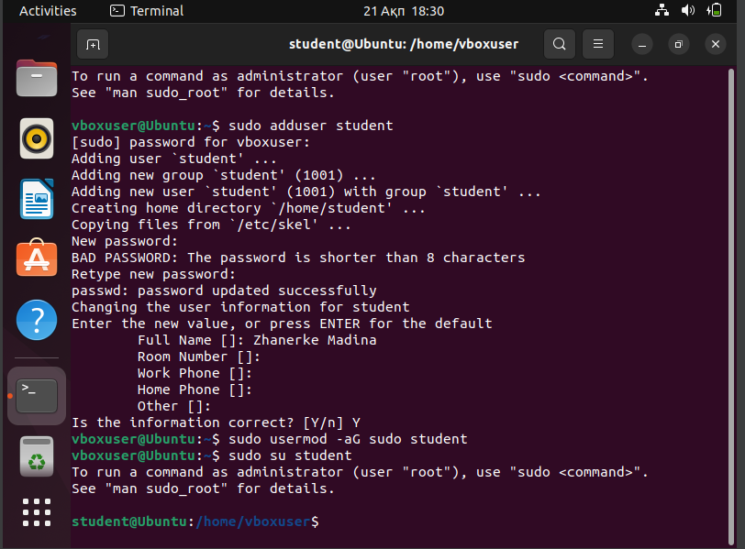

After we should login to student and password, then we should use whoami command and check the user

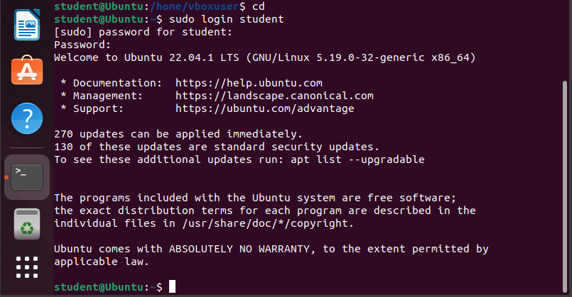

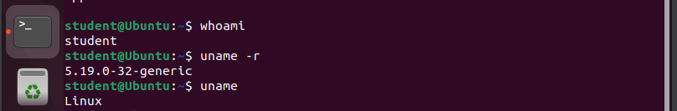



Task 2:

IP connection

In this task we should connect our virtual box Ubuntu OS IP address and DHCP add on the internet.

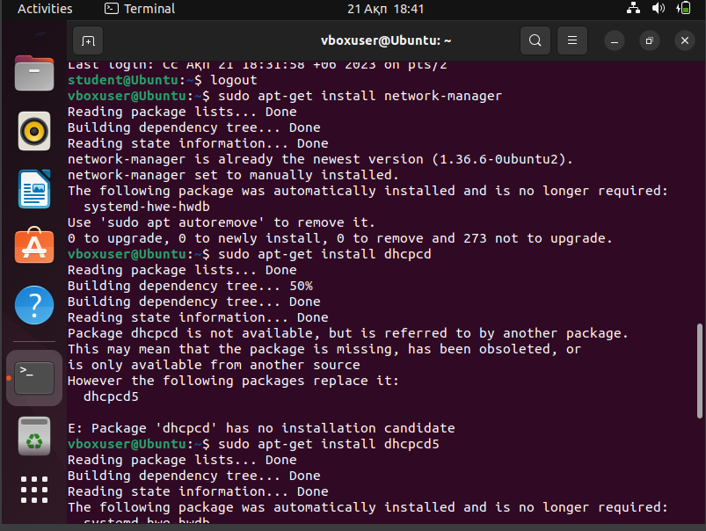

For this we need to install network manager with dhcpcd packets!

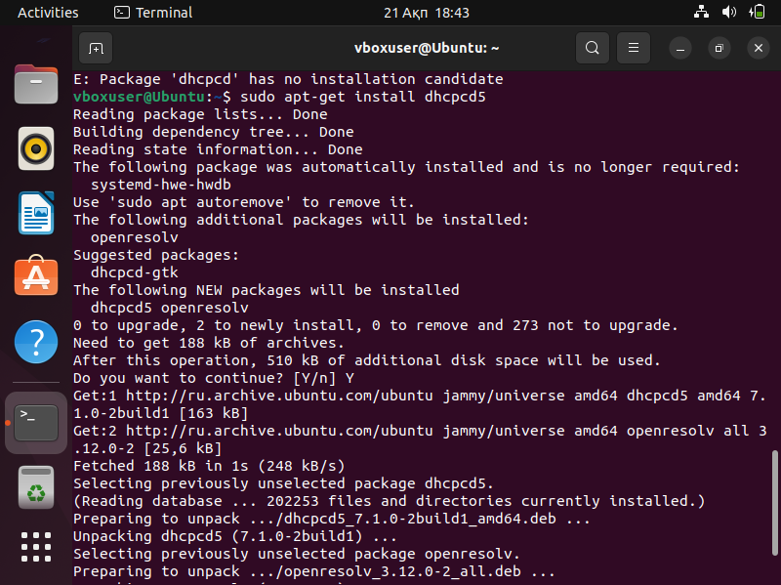

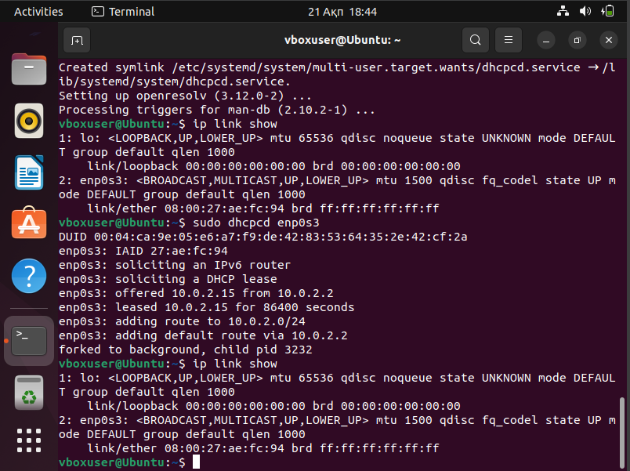

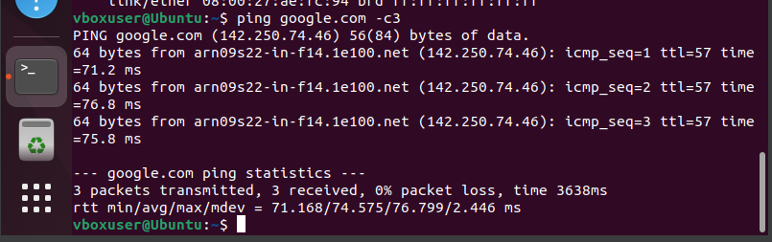

NAT

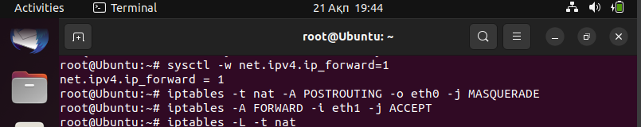

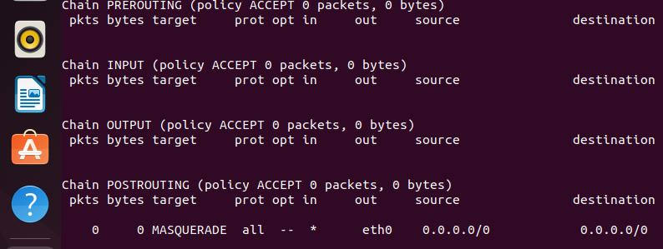

Then we should add DHCP connection to our network. For this we open the settings> find network> wired> click on DHCP

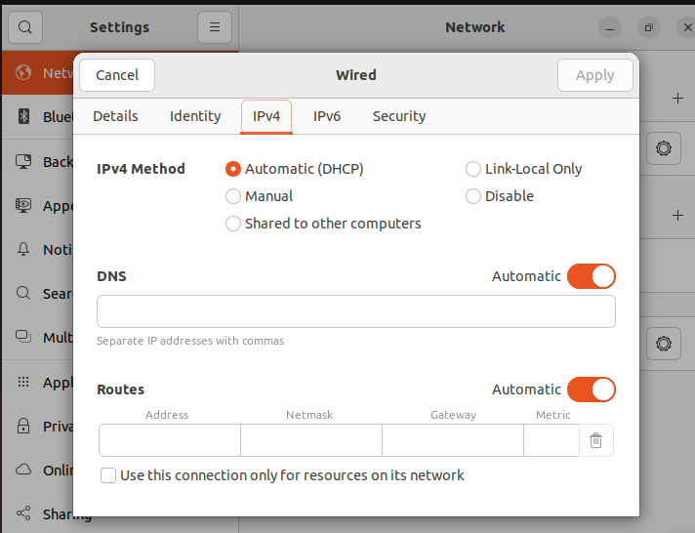

Proxy server

After connection IP; DHCP addresses we should connect to the Proxy server. For it we open setting the go to the network and at the end of page we can see network proxy. There we need to click on “Automatic” and write our url.

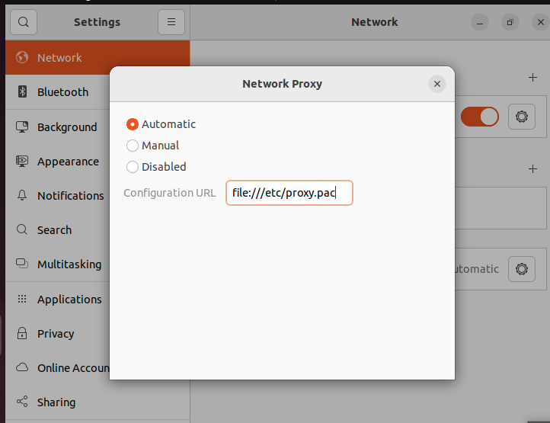

Then we should open web browser then find settings and open connection settings the also click on automatic and write our URL.

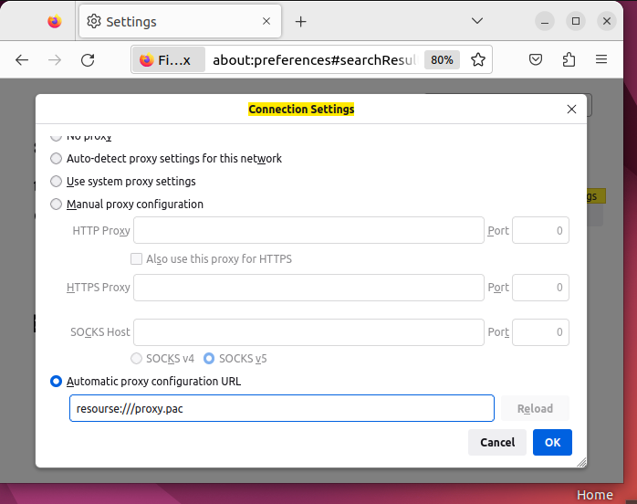

Task 3:

Checking our version of kernel with neofetch and our current kernel: 5.19.0-32-generic

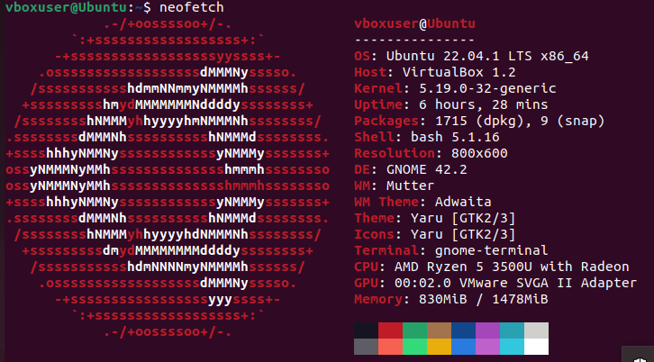

We should download Kernel original from browser

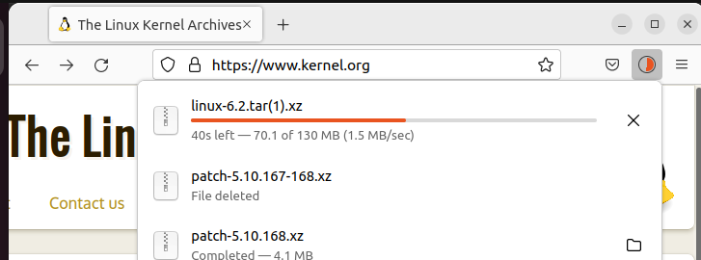

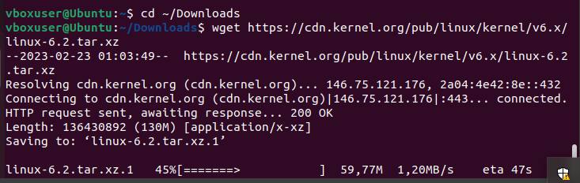

Unzipping linux kernel files

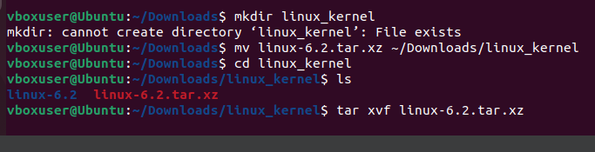

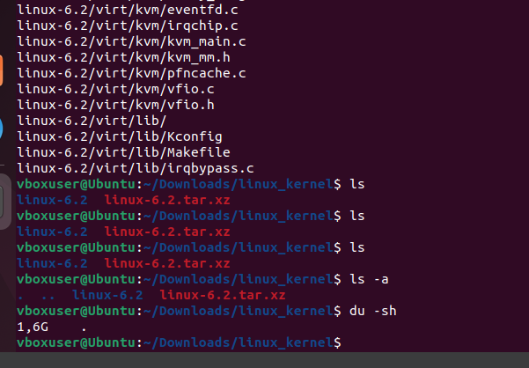

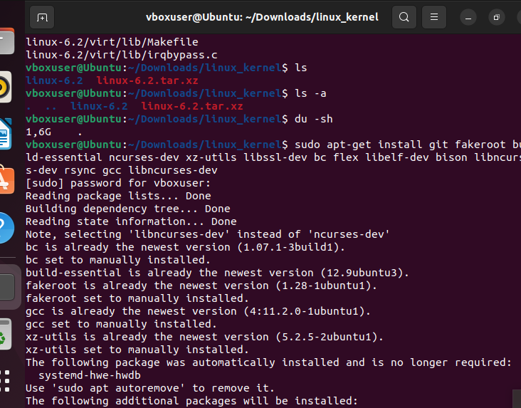

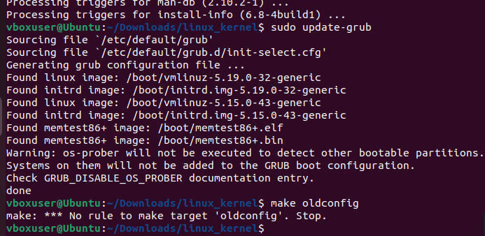

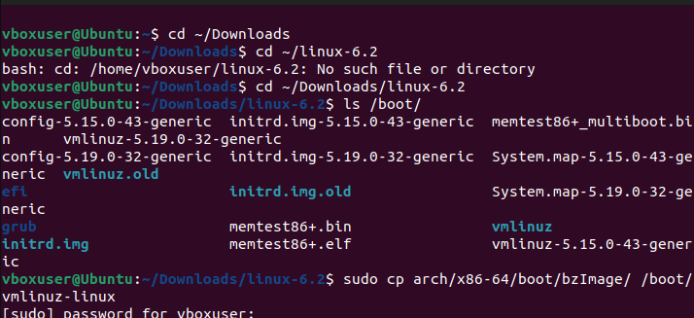

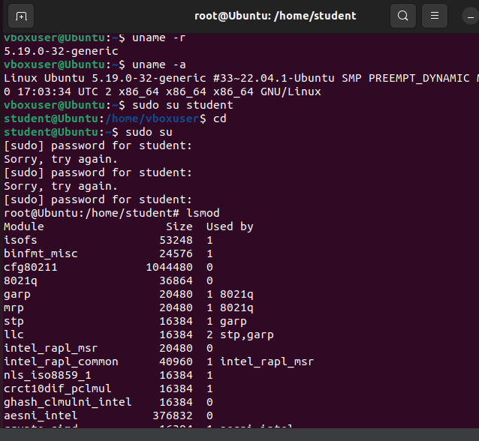

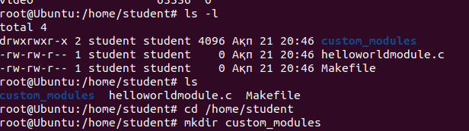

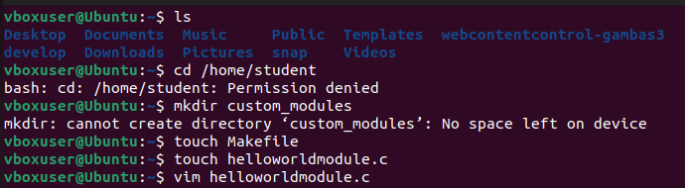

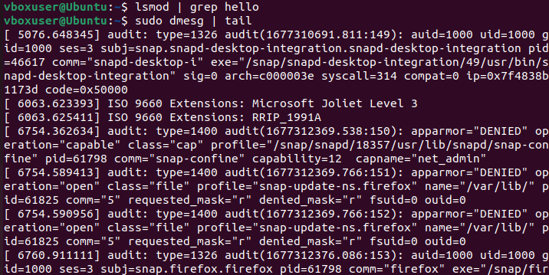

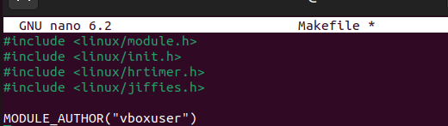

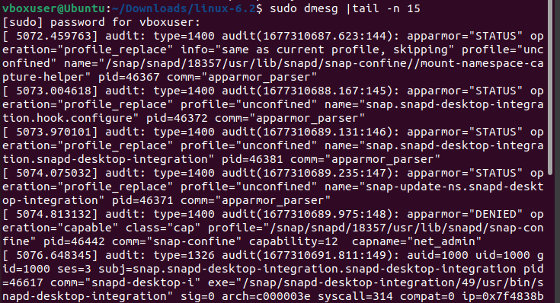

Conclusion:

So we have finished our final project on the subject of the operating system. This process of adding a new user to the OS, connecting to the Internet in various ways, creating a Linux OS kernel using kernel modules are necessary skills for our future and thanks to this subject and project we have learned a lot.

The first stage of our project was the creation of a new user in our system, then we learned how to connect our system to various Internet using IP and DHCP addresses and of course Proxy server. And our ultimate goal was to create a Linux OS kernel module